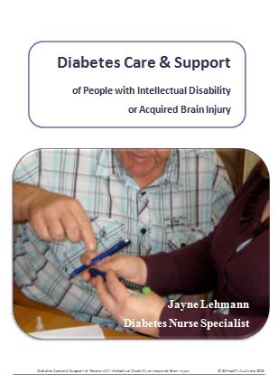A Diabetes Care and Support of People with Intellectual Disability and Acquired Brain Injury Manual is available to support quality diabetes care in people with a disability. It will be of interest to paid carers, nursing staff, family members, disability service managers and health professionals to support their care of people with diabetes and an intellectual disability or acquired brain injury.
Jayne Lehmann RN CDE has combined 30 years of clinical expertise as a Credentialled Diabetes Educator with personal experience in disability care to produce this publication and resources. Jayne explains, “People with disabilities often need an individualised approach to support them to look after their diabetes. Support workers often play a major role and need additional knowledge and skills to provide the care required. The manual and resources are designed to also address the usually low health literacy skills of people with intellectual disability or acquired brain injury.
Diabetes Care Tips are included with practical ideas and real-life, de-identified examples described to provide inspiration and ideas on using the information with people with ID/ABI.

Resources included:
- Contemporary Diabetes Care/Health Plans for use by a Credentialled Diabetes Educator, Registered Nurse or GP
- Blood glucose monitoring charts for organisations
- Low health literacy blood glucose monitoring chart
- Check, Think & Act tool to understand what blood glucose levels mean and how to act on them for improved diabetes health
- Hypoglycaemia flow chart
- Doctor/health care professional feedback sheets
- Very low literacy education handouts using Boardmaker™
- Checklists:
  - Newly diagnosed type 1 diabetes and type 2 diabetes
  - Type 2 diabetes starting insulin
  - Holiday Planning
  - Pre-hospitalisation.
The Manual and Resources are available for sale via this website’s shop.

