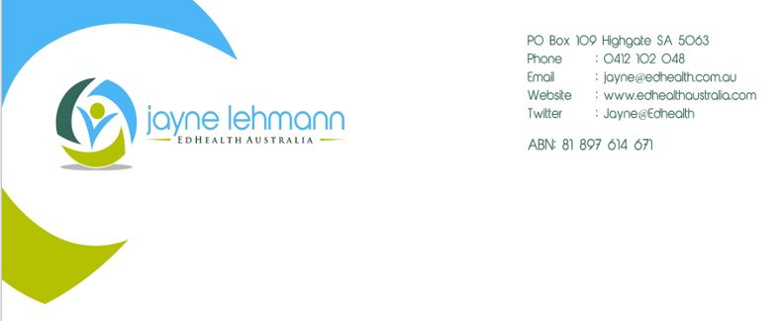

Thank you for coming along to the Roche Breakfast Session! During the session I told you about my **Sur*vival Guide to BGM Restrictions*** blogs. To find them, go to my newly launched website: [www.edhealth.com.au](http://www.edhealth.com.au) . Click on **DE@Connect**. This a new, on-line destination placing grassroots diabetes education in the spotlight. It celebrates the role diabetes educators and Credentialled Diabetes Educators play in the lives of people with diabetes in Australia and beyond. Click on the links to the blogs. There are some tables you can use as ready reckoners while getting used to the new NDSS strip access guidelines for people with type 2 diabetes not on insulin.

Do a regular drop-in to **DE@Connect** and break the isolation many CDE/DEs feel. Explore information and activities to use in your day-to-day diabetes education and support of people with diabetes. **DE@Connect** will inspire you to try something new with the tips and tricks to be shared. Check out the blogs and sign-up for future blogs - delivered directly to your inbox!

**DE@Connect** lets you find out more about social media’s role in diabetes education, keep your private practice on track or utilise the resources and guidelines in your practice to achieve high quality outcomes with people with diabetes.

 **Jayne Lehmann RN CDE**

[**www.edhealth.com.au**](http://www.edhealth.com.au) 

**Putting grassroots diabetes education in the spotlight!**

August 2016